MASK OF THE PANTHER
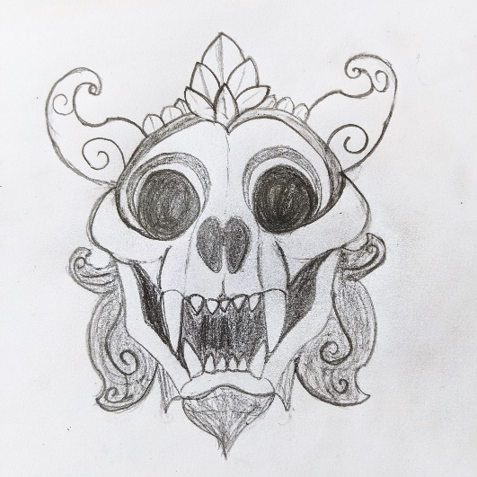
Wondrous item, rare (requires attunement)
As an action, you can command the mask to transform you into a Panther Spirit for up to 1 hour. The transformation otherwise functions as the Polymorph spell, but you can use a bonus action to revert to your normal form.

Curse. This mask is cursed and becoming attuned to it extends the curse to you. Until the curse is broken with Remove Curse or similar magic, you are unwilling to part with the cloak, keeping it within reach at all times.
The sixth time you use the cloak, and each time thereafter, you must make a DC 15 Charisma saving throw. On a failed save, the transformation lasts until dispelled or until you drop to 0 hit points, and you can't willingly return to normal form.
If you ever remain in Panther Spirit form for 6 hours, the transformation becomes permanent and you lose your sense of self. All your statistics are then replaced by those of a Panther Spirit. Thereafter, only Remove Curse or similar magic allows you to regain your identity and return to normal. If you remain in this permanent form for 6 days, only a Wish spell can reverse the transformation.
